OSLO Workstation Assessment Report
General Information
Date of Assessment |  |  |  |  |  |  | OSLO Name
Staff/Student name |  |  |  |  |  |  | OSLO Phone
Uni ID number |  |  |  | U
Phone |  |  |  |  |  |  | Supervisor
College/Division |  |  |  |  |  |  | Supervisor Phone
Reason for assessment:  ☐ New Starter ☐ Reported new pain  ☐ Relocation ☐Pre-existing pain/condition  ☐ Other……………………………………………………….. |  |  |  |  |  | Details/Comment
If new pain/injury related to work activity ensure Incident Notification (level 1 incident) completed in Figtree. ☐ Complete INC#_________
Assessment details
Chair | Seat base height adjusted so knees and hips at or slightly above 90 degrees. |  |  |  |  |  |  |  |  |  |  |  | ☐ Yes ☐ No
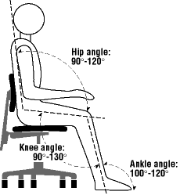 | Seat base size suitable for user. (Width supports hips, depth adjusted to allow small gap between knees and chair) |  |  |  |  |  |  |  |  |  |  |  | ☐ Yes ☐ No
 | Back rest height adjusted so lumbar support rests in users lumbar curve |  |  |  |  |  |  |  |  |  |  |  | ☐ Yes ☐ No
 | Back rest angle adjusted to support a relaxed, upright posture |  |  |  |  |  |  |  |  |  |  |  | ☐ Yes ☐ No
 | Seat base tilt adjusted to neutral |  |  |  |  |  |  |  |  |  |  |  | ☐ Yes ☐ No
 | Recommended seat base height (Floor to top of seat base) |  |  |  |  |  |  |  |  |  | cm
 | Comments:
Desk | Desk height adjustable to allow arms to be parallel to floor when typing |  |  |  |  |  |  |  |  |  |  |  | ☐ Yes ☐ No
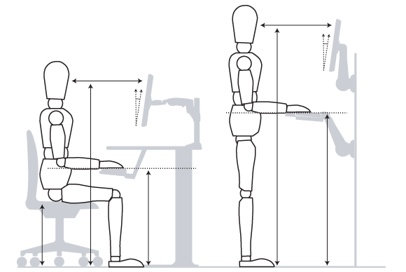 | Desk size appropriate to task requirements |  |  |  |  |  |  |  |  |  |  |  | ☐ Yes ☐ No
 | Standing desk in place |  |  |  |  |  |  |  |  |  |  |  | ☐ Yes ☐ No
 | Desk height and design allows appropriate leg clearance |  |  |  |  |  |  |  |  |  |  |  | ☐ Yes ☐ No
 | Recommended seated desk height |  |  |  |  |  |  |  |  |  | cm
 | Recommended standing desk height (Floor to top of desk surface) |  |  |  |  |  |  |  |  |  | cm
 | Comments:
Monitor | Monitor height adjusted so that line of sight is level with top tool bar on screen, or so that head in neutral position if using multi-focal glasses |  |  |  |  |  |  |  |  |  |  |  | ☐ Yes ☐ No
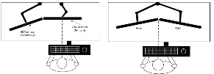  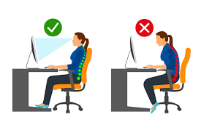 | Monitor distance from user is adjusted to roughly an arms-length, but adjust to individual need to allow comfortable viewing without moving head |  |  |  |  |  |  |  |  |  |  |  | ☐ Yes ☐ No
 | Monitor angle adjusted to suit comfort and minimise reflection or glare |  |  |  |  |  |  |  |  |  |  |  | ☐ Yes ☐ No
 | Dual monitors positioned as per graphic according to work tasks to minimise static or repetitive neck movement. |  |  |  |  |  |  |  |  |  |  |  | ☐ Yes ☐ No  ☐ N/A
 | Recommended monitor height (Desk surface to top tool bar of screen) |  |  |  |  |  |  |  |  |  | cm
 | Comments:
Documents | Document holder in place to position documents appropriately? |  |  |  |  |  |  |  |  | ☐ Yes ☐ No ☐ N/A
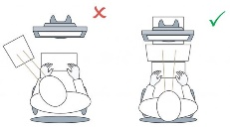 | Document holder for paper based tasks away from the computer? |  |  |  |  |  |  |  |  | ☐ Yes ☐ No ☐ N/A
 | Is there adequate storage for hard copy documents without creating clutter |  |  |  |  |  |  |  |  |  |  |  | ☐ Yes ☐ No
 | Comments:
Keyboard | Keyboard positioned centrally between the user and the computer |  |  |  |  |  |  |  |  |  |  |  | ☐ Yes ☐ No
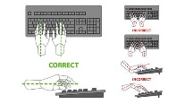 | Keyboard size appropriate to user (consider short or split keyboards) |  |  |  |  |  |  |  |  |  |  |  | ☐ Yes ☐ No
 | Keyboard flat on the desk (not elevated at rear) to minimise wrist strain |  |  |  |  |  |  |  |  |  |  |  | ☐ Yes ☐ No
 | Keyboard position (desk height) allows relaxed shoulder posture |  |  |  |  |  |  |  |  |  |  |  | ☐ Yes ☐ No
Comments:
(Note current keyboard type)
Mouse | Mouse positioned as close as possible to keyboard to minimise reaching |  |  |  |  |  |  |  |  |  |  |  | ☐ Yes ☐ No
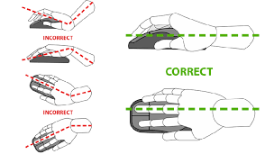 | User encouraged to alternate mouse use between left & right if comfortable |  |  |  |  |  |  |  |  |  |  |  | ☐ Yes ☐ No
 | Mouse type appropriate to users tasks and health history |  |  |  |  |  | Note current mouse type |  |  |  |  |  | ☐ Yes ☐ No
 | User familiar with keyboard shortcuts to minimise excessive mouse use |  |  |  |  |  |  |  |  |  |  |  | ☐ Yes ☐ No
Phone | Headset in place. Recommend headset for moderate, or more, phone use. |  |  |  |  |  |  |  |  |  |  |  | ☐ Yes ☐ No
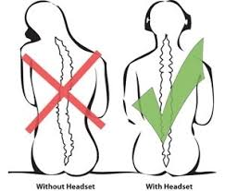 | Phone within easy reach of user |  |  |  |  |  |  |  |  |  |  |  | ☐ Yes ☐ No
 | User educated on correct phone posture and encouraged to alternate hand use during phone tasks. |  |  |  |  |  |  |  |  |  |  |  | ☐ Yes ☐ No
Lighting/sound | Room lighting appropriate for user needs |  |  |  |  |  |  |  |  |  |  |  | ☐ Yes ☐ No
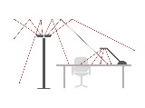 | Task lighting appropriate to user needs (where applicable) |  |  |  |  |  |  |  |  | ☐ Yes ☐ No ☐ N/A
 | User able to adjust monitor brightness and colour to suit individual needs |  |  |  |  |  |  |  |  |  |  |  | ☐ Yes ☐ No
 | Auditory environment appropriate to tasks |  |  |  |  |  |  |  |  |  |  |  | ☐ Yes ☐ No
Breaks | User encouraged to take regular posture breaks throughout the day ( rec. 2 minutes every 30 minutes as well as regular lunch/tea breaks) |  |  |  |  |  |  |  |  |  |  |  | ☐ Yes ☐ No
 | User familiar with Work Rave software to support taking regular breaks |  |  |  |  |  |  |  |  |  |  |  | ☐ Yes ☐ No
 | Recommended frequency of breaks |  |  |  |  |  |  |  | ____mins /____mins
Laptop | User has laptop riser, external mouse and keyboard for extended use |  |  |  |  |  |  |  |  | ☐ Yes ☐ No ☐ N/A
 | User educated on correct laptop postures and use |  |  |  |  |  |  |  |  | ☐ Yes ☐ No ☐ N/A
Comments:

Recommendations |  |  |  |  | Further details  (eg chair model, keyboard/mouse type, referral needs) |  |  |  |  |  |  | Person responsible for enacting these
☐ Replace current chair (with same)  ☐ Repair/replace desk  ☐ Phone headset  ☐ Laptop riser  ☐ Document holder  ☐ Footrest |  |  | ☐ Provide new (different) chair  ☐ New mouse  ☐ New Keyboard  ☐ Referral to Injury Management |  |  |  |  |  |  |  |  | Supervisor  Due Date:  (max 4wks post Ax)
☐ Implement more frequent rest and posture breaks  ☐ Implement regular visual breaks |  |  |  |  |  |  |  |  |  |  |  | Staff/Student  Due Date:  (max 4wks post Ax)
Other Item:
Other Item:
Acknowledgement
Report completed by:  ☐ OSLO ☐ WEG  Name:  Phone:  Date of report:  Report sent to  ☐ Staff/Student  ☐ Supervisor  ☐ WEG  ☐ Other………………………. |  | Supervisor responsibilities:  - Meet with staff member and provide instruction on implementing the recommendations contained in this report;  - Ensure recommendations are implemented in a timely fashion;  - Review with staff member within 6 months to ensure effectiveness.  Staff/Student responsibilities:  - Meet with supervisor and follow instructions to source equipment or implement other recommendations;  - Continue to undertake usual safe work practices;  - Notify supervisor as soon as practicable if any symptoms persist or develop.  Please keep a copy of this report for your records.  If all recommendations are implemented, any symptoms have resolved and no further action is required, please scan a copy of this form and email to your local HR team to be saved on your personnel file in ERMS.  If all recommendations are implemented but any symptoms have persisted or further assistance is required, please scan a copy of this form and email to InjuryManagement@anu.edu.au requesting further assistance.

