[Insert Project Name]
Project Planning Document

Small Project

Further description if needed

Please note: all text highlighted in grey has been developed to assist you in preparing your Project Planning Document. Please delete this text once you understand the requirements.

Document Control

Version | Date | Author | Amendment | Distribution

Document Approval

Supported by:

…………………………………………………………………….. Date: ……………………
(INSERT Business Owner name / title)

Approved by:

…………………………………………………………………….. Date: ……………………
(INSERT Project Sponsor name / title)

Table of Contents

Once you have completed this template, right click on the table below and click ‘update fields’ to finalise your table of contents.

1. Purpose 4
2. Project Definition 4
2.1 Background 4
2.2 Project Objectives 4
2.3 Scope 4
2.4 Constraints 5
2.5 Assumptions 5
2.6 Dependencies 5
2.7 Key Stakeholder Groups 5
3. Business case 5
4. Roles and responsibilities 6
5. Quality expectations and acceptance 6
6. Risk Management Plan 6
7. Communication Management Plan 6
8. Change Management 6
9. Project plan 7
9.1 Work Breakdown Structure 7
9.2 Schedule 7
9.3 Variation Process 8
9.4 Controls 8
10. Budget 8
10.1 Project 8
10.1 Ongoing 8

- Purpose
The Project Planning document defines the project to form the basis for its management and assessment of its overall success. This will be used to gain approval to proceed with the project and used as the basis against which performance will later be assessed.

- Project Definition
You can extract most of this information from the Project Brief prepared in the Start Up stage of your project.
  - Background
Provide a brief outline of any background to the project ie; rationale/drivers for the project, who commissioned the project and where does it fit within the wider picture?
  - Project Objectives
What specific outcomes will be achieved, and how will you measure these outcomes?
Tip: The project objectives should be Specific, Measurable, Achievable, Realistic and Time-bound (SMART).
Specific: Who is involved?
What do we want to accomplish?
Where – identify a location
When – establish a timeframe
Which – identify requirements and constraints
Why – specific reasons, purpose or benefits of accomplishing the objective.
Measurable: Establish concrete criteria for measuring progress toward each objective
Agreed: It is crucial measurable objectives are agreed between stakeholders.
Realistic: Make it realistic. Do you have the right resources and funding? Is it achievable?
Time based: Allocate a time frame. By when are you going to achieve the objective?

  - Scope
What are the boundaries for this project (for example, type of work, type of client, type of problem, geographic area covered)? The more specific you are, the less opportunity there is for confusion at a later stage in the project. List any areas excluded that you believe stakeholders might assume are included, but are not as Out of scope.

Stage 1 – In scope | Out of scope

Stage 2 – In scope | Out of scope
  - Constraints
What things must you take into consideration that will influence your deliverables and schedule? Are there any constraints in terms of resources, time, quality and cost?

  - Assumptions
What is assumed for the project to be successful?
  - Dependencies
Are there any dependencies that could impact on successful delivery/outcomes for your project? For example, a component of your project may not be able to start until another project is completed. These can be internal or external.
  - Key Stakeholder Groups

Stakeholder Impact: C = Critical ; E = Essential ; IP = Interested Party
Stakeholders | Impact | Comment on stakeholder impact
Office of the Vice Chancellor, including Executive Director Administration and Planning | E | Required to approve
College Deans and General Managers and Service Division Directors | IP | Required to have input and overview of the project
- Business case
Refer to the Business Case (see template).
Update the Business Case as required.

- Roles and responsibilities
You can extract and expand on this from the Project Brief in the Start Up stage. You need to be clear about staff roles so that you don't duplicate responsibilities, and so that everyone is clear about what's expected of them. You will need to document who will be on the project and their responsibilities.

Role | Responsibility | Name / position | Contact details
- Quality expectations and acceptance
You can extract and expand on this from your Project Brief

Expectation | Acceptance Criteria
Provide a brief statement about the quality expected from the people who will benefit from the end results. | Provide a list of criteria that the project must meet for the customer/stakeholders to accept it. Use the SMART method to assist in defining so it is measurable and realistic.

- Risk Management Plan
Refer to the Risk Register (see template)

- Communication Management Plan
Refer to the Communications Plan (see template)

- Change Management
This section can be included if the project is likely to lead to one or more of the following;
- Relocation of work area;
- Elimination of positions;
- Change to hours of operation;
- Introduction of significant technological change; or
- A significant change to work practices or impact on conditions, including change that would be likely to lead to changed responsibility levels.

Where Change Management is required, organisational changes occurring as part of the project should be conducted in accordance with the ANU Enterprise Agreement (Section 73- Managing Change) and the ANU Organisational Arrangements Change Procedure.

This section should describe the planned change management activities that will need to take place as part of the project.

- Project plan
  - Work Breakdown Structure
Provide a high level overview of the project effort. The Work Breakdown Structure will assist in developing the Project Schedule. This can be mapped in a simple structural diagram such as the one below (using MS Word Smart Art Org Chart tools).

Example: Work Breakdown Structure for a “Conference”

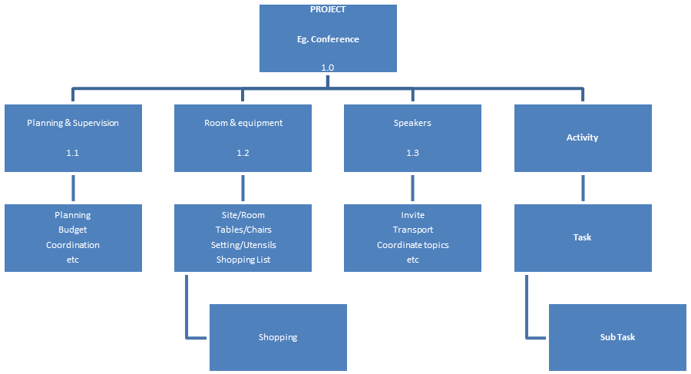
  - Schedule
Insert a high level Gantt chart incorporating critical path and key milestones. This is a high level schedule for project activities.

OR use the table below

ID | Activity | Description | Who | Scheduled start | Scheduled Finish | Predecessor
1
2 |  |  |  |  |  | e.g. 1
3 |  |  |  |  |  | e.g. 2
4

- Activities in the Predecessor column must be completed prior to this activity commencing
  - Variation Process
Outline the process that will be taken in the event that the project needs a variation request. What constitutes a variation that needs to be approved? Who is responsible for developing the variation request? Who is authorised to approve it?
  - Controls
Detail what controls you will use to track progress and report to the defined governance group.

Control | Frequency | Responsibility
Update and submit Project Status Reports to Project Board
Update and submit updated issue/risk register to Project Board
Update and submit Lessons log to project Board

- Budget
Breakdown of the elements considered when estimating the budget. Use the Budget Management Template to estimate and document project costs.

Please see the attached Budget Management Template that provides a detailed cost estimate for the project. This Budget Management Template should accompany the Project Planning Document for approval.

A summary of project costs (including ongoing operations and maintenance costs) and where they will be funded from is provided in the table below.
  - Project

Type | Cost | Funding Source | Approved By
External
Proposing Area
Impacted Area(s)
Total
Comments:

  - Ongoing

Type | Cost per Annum | Funding Source | Approved By
Staff
Licensing
Maintenance
Total
Comments:

