Safety Awareness
Wild Mushroom Precautions

At the ANU, we are seeing an abundance of wild mushrooms as wet and cooler weather provides the ideal growing conditions for certain types of mushrooms.

Wild mushrooms can pop up quickly and may look inviting to touch and eat but ingesting them can cause serious illness or death. It is difficult to distinguish between poisonous and edible wild mushrooms, so people are advised to only consume commercially bought mushrooms.

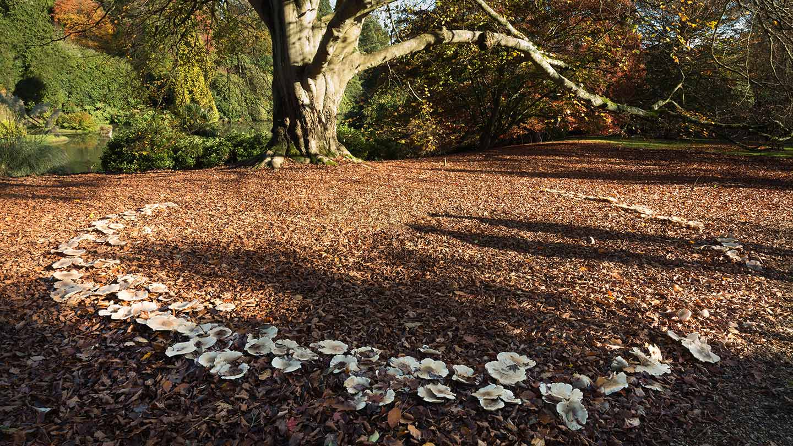

Poisoning generally occurs 6–24 hours or more after ingestion. Symptoms of mushroom poisoning include:
- Severe stomach cramps
- Nausea
- Vomiting
- Diarrhoea
- Life-threatening liver damage
- Death

If poisoning is suspected, please attend a hospital emergency department immediately.
Further information and assistance can be sought from:
- Poisons Information Centre on 13 11 26
- ACT Health https://www.health.act.gov.au/about-our-health-system/population-health/death-cap-mushrooms

