Document 021: Wildlife Survey and Trapping Guidelines V1.0

Background
The purpose of this document is to provide guidance on acceptable techniques of surveying and trapping of wildlife as they pertain to the species and other factors that may have an impact on the welfare of the animal. Methods that are selected should be appropriate for the target species and must be designed and carried out in a way that will minimise pain and distress to the animal and within the shortest possible time.
As per the NHMRC's Code Section 3.3.35: "If trapping is used to capture wildlife, the wellbeing of both target and non-target animals must be considered by:
1. selecting a trap that is suited to the species and the circumstances, and designed to ensure protection of trapped animals from injury, predators, parasites and environmental extremes
2. monitoring traps to minimise the time animals will spend in traps, and to avoid or minimise adverse impacts on trapped animals
3. minimising the number of days of continuous trapping within an area, and removing or deactivating traps that are not in use or are no longer required
4. minimising the potential adverse impact caused by disrupting social structure, and adverse impacts on dependent young (e.g. by avoiding trapping in the breeding season)
5. minimising the numbers of non-target species that are trapped, and implementing a management plan for captured non-target species to ensure their wellbeing or ensure that they are humanely killed."
The method of used must be In accordance with current best practice.

Definitions
Camera trap - A remotely activated camera that is equipped with a motion sensor or an infrared sensor, or uses a light beam as a trigger.
Trapping - the process of capturing an animal remotely through physical means
Target Species - animal intended to be caught during trapping
Bycatch - non target animals that are caught during trapping
Refinement - selection of processes or techniques to reduce impact on animals

General Information and Considerations

Skills
Any researchers, students, staff and volunteers undertaking wildlife research must have the required skills in handling and trapping, as well as knowledge of the target species ecology and behaviour. A trapping team should include enough skilled people to ensure that all traps can be set, located and cleared in a timely and efficient manner. Any inexperienced students and researchers may also participate in trapping but must be under the direct supervision of the experienced researcher. Researchers require approval from the AEC prior to undertaking any trapping program. Researchers must hold appropriate authority and endorsement from the Australian Bird and Bat Banding Scheme to conduct mist netting, which requires extensive training under the supervision of experts in the field.

Trap selection and placement
The selection of the trap should be appropriate to the target species and should be in line with latest research for optimum welfare. All traps should be:
- checked to be clean and in good working order before they are used
- be secured to the area it is to be set to prevent movement and rolling in the trap. Mist nets must be securely anchored and placed in a sheltered position. Harp traps should be set in protected positions and should be secured so that they do not tip over.
- easily located with a clear indicator such as flagging tape, with the tape placed in a way to avoid drawing the attention of the general public (i.e away from walking paths).
- traps and flagging tape should be numbered and positioned sequentially and in a grid or transect at regular intervals, with spacing appropriate to the species, number of traps and aims of the trapping sessions. A common distances between traps for small mammal monitoring are around 5-10m in vegetation dense areas and 10-20m in more open habitat.
- Each trap or the start and end points of trapping lines should be recorded using a Global Positioning System (GPS), both to aid in re-finding the traps and meeting reporting requirements.
Ensure that all traps are located when checking and at the end of the survey, they are all removed or closed and locked. This includes counting out and counting in the traps at the beginning and end of the sessions. Traps must be thoroughly cleaned between trapping periods, ideally with warm soapy water.

Refinement
Where possible, options to minimise handling and capture stress should be selected. These may include the use of inkpads or camera traps.

Permit requirements
The primary investigator and any participants in the research must ensure that all required permits to capture and release the target species are organised and approved well before the start of the research. Requirements vary from state to state and the researcher should be aware of the conditions of the permit and should abide to any necessary requirements under the relevant legislation as it applies to their research activities.

Animal Handling
The animal should be handled by an experienced handler in line with current best practice. Any noise, lights and activity should be kept to a minimum and the animal should be removed from the trap as soon as possible and placed in a species appropriate, secure holding vessel. The material strength and size of the bag used should be appropriate for the species, such that the animal is easy to control but cannot easily escape (eg calico bag for small mammals, plastic container for frogs). The animal should be handled in a way that ensures that the eyes are covered as much as possible to reduce stress.
In some circumstances, for the safety of the animal and the handler it may be best to apply chemical restraint or immobilisation. This is dependent on the species of the animal, temperament, danger to the handler and the requirements for sampling and how invasive these may be. The need for sedation should be discussed with the ANU veterinarians beforehand, with the sedation protocol outlining the capture plan, drug and doses clearly outlined in the approved protocol.

Timing and duration of trapping activities
Consideration must be taken to the timing of the trapping to avoid times when the animal are susceptible to greater stress. This means knowing the biological parameters of the species and breeding times. If possible, the researcher should avoid trapping during the breeding season or seasons when the animals are likely to be in poorer body condition (lean season).
Trapping should also be avoided in weather conditions that may compromise the welfare of the trapped animal. Where possible, researchers should consider the impact of weather conditions and should make provisions (eg padding or insulation). This material should not affect the functioning of the trap or hold any human scent. The traps should be set under foliage or dense vegetation to provide some protection to the animals. Additionally, the location selected should be free of hazards that may harm the animal eg ant nest. Trapping must be suspended if adverse weather conditions that will impact the animal are predicted. Depending on the susceptibility of the species, traps should be closed at the beginning of any day where the temperature is forecast to exceed 30°C, or if the day is declared a day of total fire ban within the region. Suspension should be considered if temperatures are expected to drop below 0C (depending on the species susceptibility) or heavy winds or rain are expected.
Traps must be checked as soon as possible after sunrise for nocturnal animals to reduce exposure to predation or unsuitable temperatures in the trap and on release. Traps should be checked in the morning and in the evening after sunset for diurnal animals, with checking intervals not exceeding 12 hours. Mist nets should only be used in favourable weather conditions and must be checked at least every 25-30 minutes (more frequently in warmer or cooler conditions or if predators are present). Harp traps should be checked in the evening at once (after 10pm) after the peak of bat activity in the early evening. Traps should be checked within 3 hours of sunrise, earlier if the weather is expected to be warm.
Food/ bait provided should be appropriate for the species, as well as potential non-target species. Consideration should be given to nutritional support that may be needed if the animals are held in the traps for an extended period of time, eg, adding a moist food item such as apple to provide hydration to animals during warm conditions.

Releasing Animals
Animals must be released at or as close to the point of capture as possible. They should also be released at an appropriate time to ensure that they are not susceptible to predation or unsuitable temperatures i.e nocturnal animals should be released prior to sunrise and after sunset.

Hygiene

All equipment that comes into direct contact with animals should be disinfected or sterilised before being used on a new animal. All organic material such as tissue, dirt and body fluids should be removed prior to disinfection. Bags and boxes should be cleaned between sessions and animals with warm soapy water, with enough for each session, as well as a way to clean containers reliably. Ethanol is recommended for items used in processing the animals, including genetic sampling.
For vehicles, tray where animals have been processed or where traps have been stored should be cleaned between sites, including hosing, disinfecting with bleach and rinsing with water. The wheels/tyres, underbody and trays should be hosed when moving between properties.
Some species have specific hygiene protocols to prevent the spread of infectious diseases amongst individuals eg chytrid fungus in amphibians. The researcher should be aware of these requirements and these should be outlined in the approved ethics protocol.
Some areas of protected or farmland may have specific biosecurity requirements and the researcher should be aware of these prior to the start of the research.

Health and Safety
As per ANU guidelines researchers must complete a risk assessment prior to undertaking any trapping activities. Handling of animals presents risk to the researcher both through physical trauma such as bites and scratches as well as the potential of transfer of zoonotic diseases (eg salmonella in reptiles, lyssavirus in bats). The researcher should have knowledge of the risks involved and the precaution taken to minimise exposure must be clearly outlined in the approved ethics protocol.

Euthanasia
If under any circumstance euthanasia is required, the method must be carried out by a skilled operator using the technique appropriate for the species or taken to a veterinary clinic that has been arranged by the researcher prior to the start of research (see 016 Field Euthanasia Guidelines).

Monitoring, Intervention and Reporting
Any trapping and Intervention must be clearly recorded on a monitoring sheet which is approved under the current protocol - this includes the person performing the procedures, any handling, samples and measurements taken, the individual animals identification and signalment, time during handling and any other observations noted. Data recording should be undertaken by persons with a clear understanding of what is required and can clearly communicate both verbally (with the handler) and in writing so that data recorded is legible.
Researchers must comply with all reporting requirements under the relevant permit and legislation of the state in which they are conducting the research. The researcher must submit annual reports to the Australian National University's Animal Ethics and Experimentation Committee (AEEC). Additionally if there are any occurrences that are not foreseen and impact research and animal welfare, a report in the form of an unexpected adverse report (UAE) must be submitted which will then be assessed by the AEEC at their next meeting (see Procedure for Managing & Reporting Unexpected Adverse Events). These include events such as traps left out open, traps not closing properly, bycatch and simultaneous catch of multiple animals, hypothermia caused by exposure to elements.

Minimum Requirements
- Traps must be appropriate for the target species and must not be harmful to non-target species
- Trapping distances and numbers should be appropriate to the research aims.
- Trapping must be undertaken with appropriate permits and by personnel trained and skilled in the technques to be utilised.
- It is recommended that trapping activities be organised so that the shortest amount of time is spent trapping and holding the animals while still achieving usable research data.
- Traps must be checked at the end of each trapping session and checking intervals must not exceed 12hrs and an appropriate amount of support in form of wet/moist food should be provided to the animal if it will be in the trap for this period.
- Researchers must ensure that location selected is free of hazards that could cause injury or death (eg ant nests).
- Mist nets must be checked at least every 25-30 minutes. If there are predators such as currawongs around, the nets must be monitored constantly.
- Mist nets must not be utilised in poor weather
- Harp traps must checked at a minimum once after the peak period of bat activity and bats should be removed within at least 3 hours of sunrise.
- Animals must be released at a time that is biologically appropriate and will not impact their ability to find food or escape predation
- Traps and all equipment that comes into contact with animals must be disinfected appropriately at the end of each trapping session, with any equipment used on multiple animals to be disinfected between uses. Mist nest can be disinfected at end of a single netting session, as multiple birds can be caught in this session.
- Hygiene measures should be appropriate for the target species and requirements for sampling.
- All traps must be counted out and counted back in for each and every session.
- All traps must be GPS tagged or at a minimum the start and end point of the transect should be tagged if the trap markings are visible from the previous trap.

Appendices
Appendix 1: Commonly used traps
Cage Trap
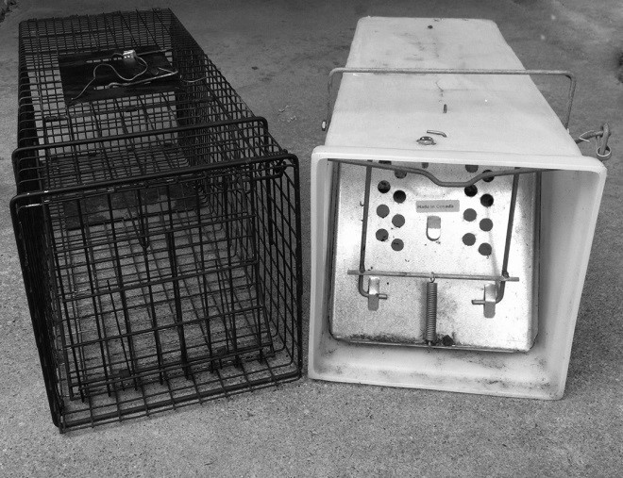
Spring and treadle mechanism operated wire or mesh traps designed for small to medium mammals
Elliot Traps
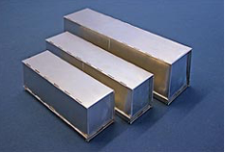
An aluminium folding trap suitable for small mammals and some reptiles.
Pitfall Traps
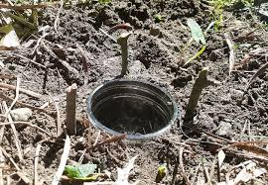
Traps with opening set flush to the ground with a depth that target species are unable to escape once they fall in. Suitable for small mammals, frogs and reptiles.

Mist Nets
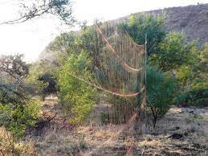
Mist nets work by entangling flying animals is a fine mesh net strung between two poles and positioned across likely animal flight paths. Mist nets are used for birds and in some cases microbats.

Harp Trap
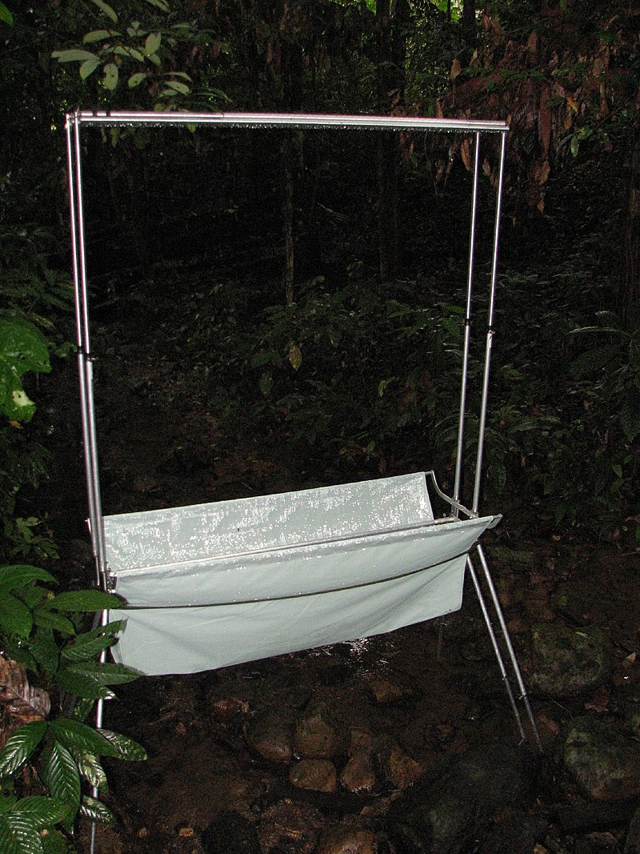
By Rob and Stephanie Levy - Harp-style bat trap, CC BY 2.0, https://commons.wikimedia.org/w/index.php?curid=61495652
Harp traps consist of two banks of vertical fishing line arranged in a frame on an adjustable set of legs. They are designed to catch microbats flying 1 to 4 metres above the ground, with the animals hitting the line and falling into a canvas bag at the bottom of the lines.

References and Resources
Procedure for Managing & Reporting Unexpected Adverse Events https://services.anu.edu.au/research-support/ethics-integrity/animal-ethics-policies-guidelines-and-forms
Document 016 Field Euthanasia Guidelines https://services.anu.edu.au/research-support/ethics-integrity/animal-ethics-policies-guidelines-and-forms
NHMRC. Australian code for the care and use of animals for scientific purposes 8th Edition 2013 (Section 3.3.33) https://www.nhmrc.gov.au/about-us/publications/australian-code-care-and-use-animals-scientific-purposes
Australian Wildlife Conservancy https://www.environment.gov.au/system/files/pages/a8cac765-28ca-4da4-9195-9069626f04a1/files/e2016-0120-application-attachment-handling-guidelines.pdf
NSW Department of Primary Industries and Animal Research - Use of pitfall traps https://www.animalethics.org.au/policies-and-guidelines/wildlife-research
Powell, R.A. & Proulx, G. (2003) Trapping and marking terrestrial mammals for research: integrating ethics, performance criteria, techniques and common sense, ILAR Journal, 44(4): 259-276 https://academic.oup.com/ilarjournal/article/44/4/259/764406
Palmer, G, School Health and Life Science, Federation University Australia https://federation.edu.au/__data/assets/pdf_file/0019/151606/Fed-Uni-General-Guidelines-for-Wildlife-Capture-and-Handling_-2018.pdf

