

Approach to Market
To establish Contract for NEA-Technical Expert Reference Group (TERG)
Reference ID: ATM_2026_6984
UNSPSC: 77101707 Ecological Advisory Services
This Approach to Market (ATM) is for the provision of up to 10 members to be appointed to a new National Ecosystem Accounts (NEA) Technical Expert Reference Group (TERG). The purpose of the TERG is to provide independent, expert technical advice to support development and continuous improvement of NEA. The TERG will comprise members with expertise in ecology and biodiversity science, environmental economics, environmental-economic accounting and spatial data architecture.
The Commonwealth of Australia as represented by Department of Climate Change, Energy, the Environment and Water (the Customer) is seeking submissions for the provision of the services (the Requirement) as described in this ATM comprising:
- this CCS ATM, including the Statement of Requirement
- the CCS ATM Response Form
- the CCS ATM Annexes (if any)
- the Commonwealth ATM Terms
- the Non-Statutory Terms of Engagement for the National Ecosystem Accounts Technical Expert Reference Group (the Terms of Engagement)
- the Commonwealth Contracting Suite Glossary and Interpretation.
In submitting a response, Potential Suppliers are required to comply with all requirements set out in the Commonwealth Approach to Market Terms (a copy of which is included in this document), and if successful, agree to enter into the Terms of Engagement (Annex A.) References to ‘Contract’ in this ATM should be read as referring to the Terms of Engagement.
The Selling to Government website provides information to help businesses understand how to sell to the Australian Government. If you have any general questions about how the Australian Government procures goods and services, please contact the Selling to Government team at sellingtogov@finance.gov.au.
For questions relating specifically to this ATM, please contact the ATM Contact Officer set out at A.A.5(a).

A.A.1 Key Information and Dates
Approach to Market
Event | Details
ATM Closing Date | Friday, 28 August 2026
ATM Closing Time | 2:00pm AEST
Question Closing Date and Time | Questions will be permitted up until 5:00pm Friday, 14 August 2026, AEST.
Minimum Content and Format Requirements | For a Potential Supplier’s Response to be eligible for consideration the Potential Supplier’s Response must comply with the matters addressed in A.B.4.2 of the Commonwealth ATM Terms.
Conditions for Participation | The Customer will exclude from participation any Potential Supplier that does not demonstrate compliance with:  - Be an Australian Resident  - Hold relevant postgraduate qualification(s) and/or at least 10 years of professional experience in nominated areas of expertise as specified in section 2.2 of the Potential Supplier’s Response
Proposed Contract
Event | Details
Proposed Start Date: | Monday, 5 October 2026
Contract Term: | The Contract will remain in force for a period of 12 Months from the date the Contract is entered into.
Contract Extension Option | The Contract will include the following extension option(s): 12 Months.

A.A.2 The Requirement
Overview
The Department of Climate Change, Energy, the Environment and Water (DCCEEW) or (the Department) seeks to establish a Technical Expert Reference Group (TERG) of up to ten experts to provide independent expert advice on the development of Australia’s National Ecosystem Accounts (NEA).
The role of the TERG is to provide expert advice on:
- The environmental and economic robustness and relevance of natural capital accounting concepts, methods and data choices for national scale implementation.
- Consistency of methods with the System of Environmental-Economic Accounting and System of National Accounts frameworks.
The TERG’s advice will cover terrestrial, freshwater, marine and coastal ecosystems, consistent with the spatial scale of the NEA. The scope of expertise required encompasses environmental science, environmental economics, environmental-economic accounting and data architecture.
The TERG will form part of the long-term governance arrangements for the NEA, alongside new user reference groups also being established to provide advice on user needs.
Background to the National Ecosystem Accounts
On 1 July 2026, the Environment Information Australia Act 2025 (the Act) came into force. The Act establishes the role of the Head of Environment Information Australia (EIA). Alongside this, the Act seeks to improve access to environmental information and data, and improve accountability through regular, comprehensive and transparent reporting.
One of the legislated functions of the Head of EIA is to establish and maintain environmental-economic accounts, with the assistance of the Australian Bureau of Statistics (ABS). The NEA support this requirement.
The NEA are intended to provide ongoing, reliable information on Australia’s environment and the services it provides to people. The NEA were first published in February 2025, with a second release in April 2026. The intention is that future annual releases update and improve on each prior release.
The NEA are available on the ABS website and via a spatial dashboard published by EIA.
To produce reliable and robust information, EIA needs technical expertise across a range of subject areas relevant to the NEA. Technical expertise is needed to critically assess methodologies, datasets and assumptions, and identify strengths, limitations and uncertainties. Technical experts who can communicate and collaborate across disciplines and provide practical and decision-relevant advice to non-experts, are critical to the future success of the NEA. To ensure that the NEA have an enduring and respected foundation, technical expertise needs to reflect not only diverse subject matter expertise but also the diversity of Australian society more generally.
Expectations for the TERG
The TERG is intended to operate as a flexible advisory mechanism to help ensure that the NEA deliver high quality, useful information. Advice required will vary across the term of appointment depending on the needs of the NEA program at the time and the expertise and availability of TERG members.
TERG members will provide advice in meetings, informal discussions and via email, to a maximum of 10 days of input per member per year. TERG members will be appointed for 12 months, with possible extension of a further 12 months.
The Terms of Reference for the TERG are provided in Annex B. Payment for TERG members is set at $570 per day (GST exclusive) plus superannuation if applicable. This mirrors the current Remuneration Tribunal Rate for CSIRO Advisory Committee members.

Evaluation process
Submissions will be evaluated by a tender assessment panel from the Department. Potential Suppliers may be approached by the Contact Officer to provide clarification of details within their response.
The evaluation process consists of the following stages:
- Stage 1 – Preliminary Registration
- Stage 2 – Initial Screening of Tenders
- Stage 3 – Detailed Evaluation of Tenders
- Stage 4 – Investigations and Referee Checks; and
- Stage 5 – Tender Evaluation Report

Additional Selection Criteria
In addition to the selection criteria are set out in clause 5.3 of the Commonwealth ATM Terms, the following selection criteria will also apply:
- Demonstrated subject-matter expertise – members must have expertise in one or more areas relevant to ecosystem accounting, preferably at large spatial scales
  - Developing accounts in the United Nations SEEA framework, official statistics production or accounts production at large scales
  - Ecosystem extent, condition and biodiversity measurement
  - Environmental economics
  - Spatial data architecture and intelligence systems
A.A.2(b) Standards
Potential Suppliers must ensure that any goods and services proposed are capable of complying with all applicable Australian standards and any Australian and international standards specified in this Statement of Requirement. Potential Suppliers should note that they may be required to enable the Customer, or an independent assessor, to conduct periodic audits to confirm compliance with those standards.
Web Content Accessibility
The Supplier must ensure that any website, associated material and/or online publications (where applicable) complies with the Web Content Accessibility Guidelines available at: https://www.w3.org/WAI/intro/wcag.
A.A.2(c) Security Requirements
None Specified
A.A.2(d) Work Health and Safety
Prior to commencement of the Contract, the Customer’s Contract Manager and the Supplier’s Contract Manager will identify any potential work health and safety (WHS) issues anticipated to arise during the term of the contract and assign management of each issue identified to the party best able to manage it. For all issues assigned to the Supplier, the Supplier will provide the Customer with a WHS plan for approval and no work will commence until the plan is approved unless agreed in writing by the Customer.
Throughout the Contract Term, the Customer and the Supplier will proactively identify and cooperate to manage any WHS issues that arise.
A.A.2(e) Delivery and Acceptance
The Customer must accept or reject any deliverables under the Contract in accordance with the Commonwealth Contract Terms [Clause C.C.11].
A.A.2(f) Meetings
The Supplier will be required to attend meetings as follows:
Meeting Type | Position Required |  | Frequency | Mode | Location
As per TERG Terms of Reference | TERG member |  | As per Terms of Reference | Videoconference | Online
A.A.2(g) Facilities and Assistance Offered by the Customer
The Customer will not make any facilities or assistance available to the Supplier.
A.A.2(h) Customer Material
The customer will provide departmental reports and information where relevant for the provision of services.
A.A.2(i) Australian business requirement
The Supplier must ensure that they are an ‘Australian business’ for the purpose of paragraph 5.4 of the Commonwealth Procurement Rules.

A.A.3 ATM Distribution
AusTender Distribution
This ATM and any updates are subject to the AusTender Terms of Use. Any updates to this ATM will be distributed via AusTender.
AusTender is the Australian Government’s procurement information system. Access to and use of AusTender is subject to the AusTender Terms of Use. In participating in this ATM process, Potential Suppliers must comply with the AusTender Terms of Use and any applicable instructions, processes, procedures and recommendations as advised on AusTender.
A.A.4 Lodgement of Responses
AusTender
Responses must be lodged electronically via AusTender before the Closing Time and in accordance with the Response lodgement procedures set out in this ATM documentation and on AusTender.
All queries for technical or operational support must be directed to the AusTender Help Desk. Contact details are available on the Contact Us page of the AusTender website.
The Closing Time will be displayed on the relevant AusTender webpage together with a countdown clock that displays, in real time, the time left until Closing Time (for more information refer to AusTender Terms of Use).
For the purpose of determining whether a Response has been lodged before the Closing Time, the countdown clock will be conclusive.
Response File Format, Naming Convention and Size
The Customer will accept Responses lodged in the following formats:
- Microsoft Word (.docx)
- PDF (.pdf)
The Response file name/s should:
- incorporate the Potential Supplier’s full legal organisation name; and
- reflect the various parts of the bid they represent (where the Response comprises multiple files).
Response files must not exceed a combined file size of 5 megabytes per upload.
Responses must be completely self-contained. No embedded files can be included. No hyperlinked or other material may be incorporated by reference.

A.A.5 Customer’s Contact Officers
A.A.5(a) ATM Contact Officer
For all matters relating to this ATM, the Contact Officer is:
Name/Position: Moi Odubasa, Senior Policy Officer
Email Address: EEA@dcceew.gov.au
Note: Question Closing Date and Time is set out at item A.A.1 [Key Information and Dates].
A.A.5(b) Complaints Handling
Complaints relating to this ATM should be directed to:
Name/Position: | Central Procurement Team
Email Address: | procurement@dcceew.gov.au
Information relating to the handling of complaints is available on the Customer’s website at: www.dcceew.gov.au.
If your issue is not resolved refer https://www.finance.gov.au/business/procurement/complaints-handling-charter-complaints for more information relating to complaints.

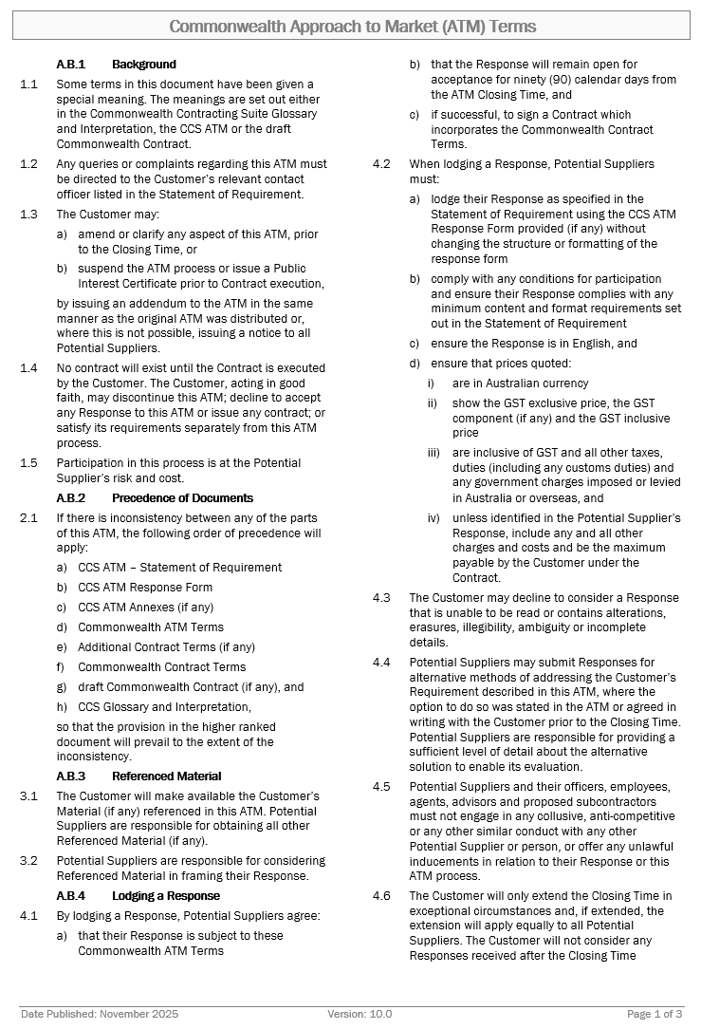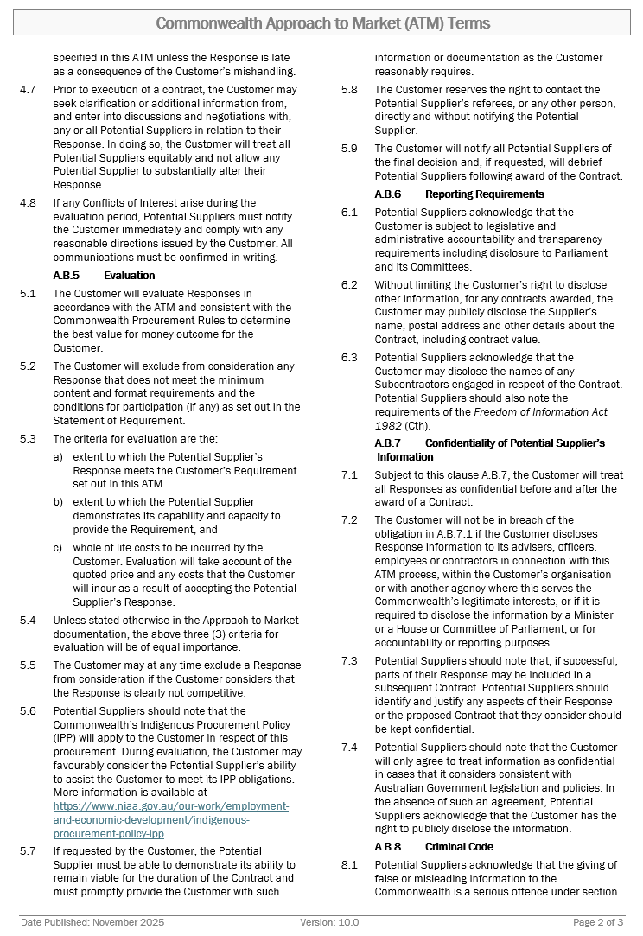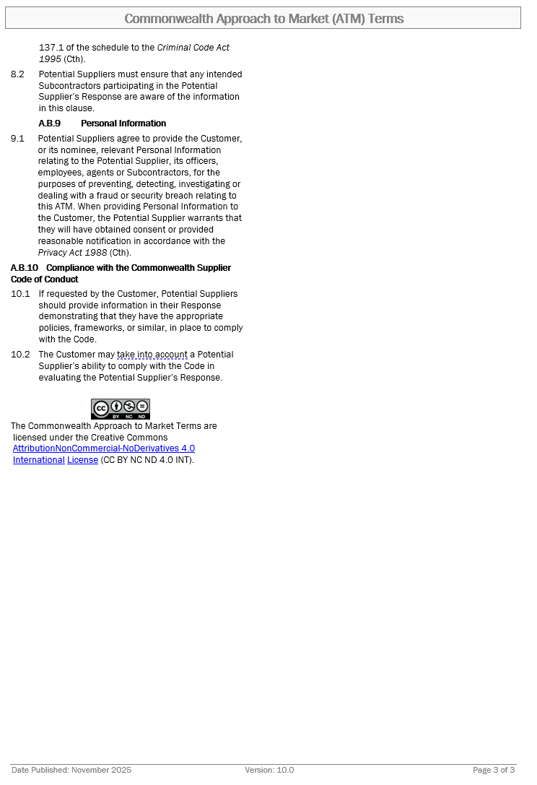
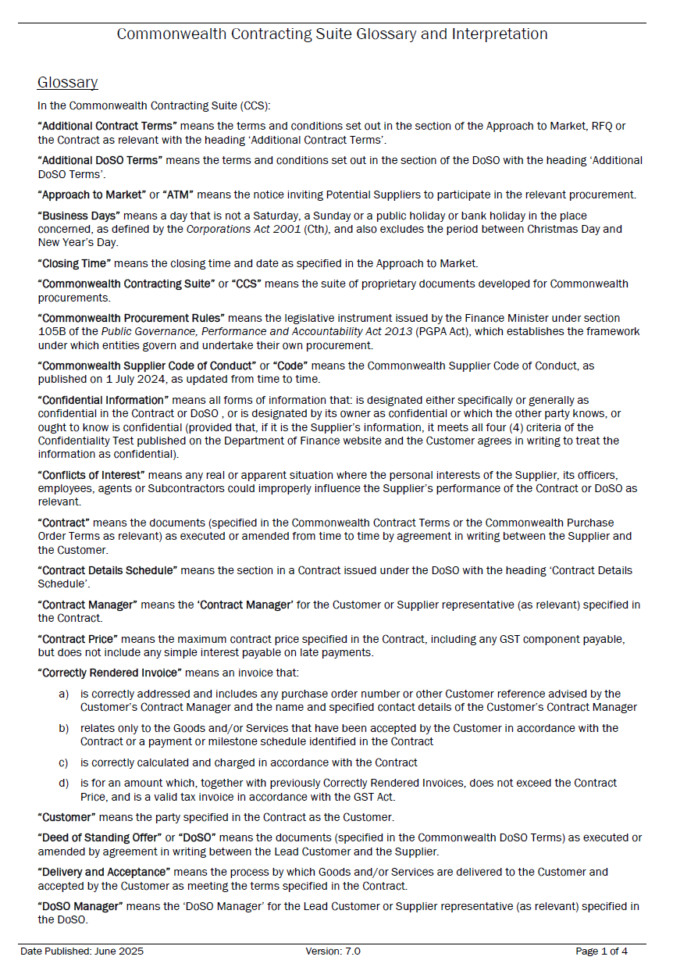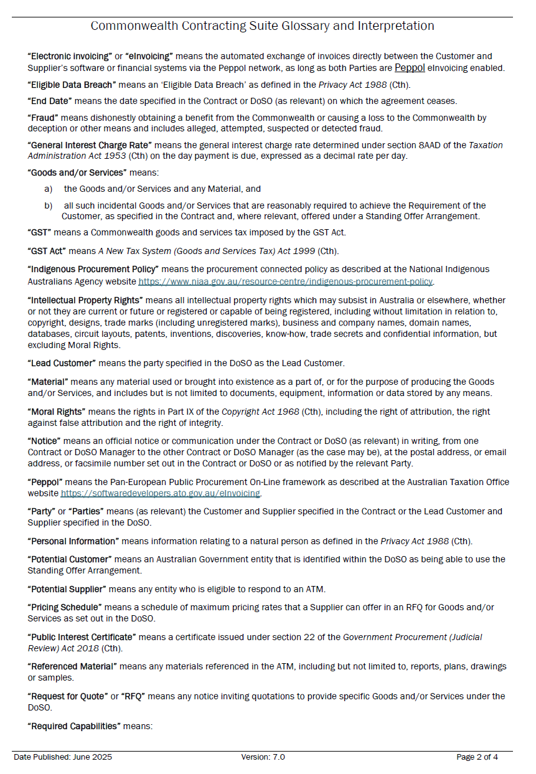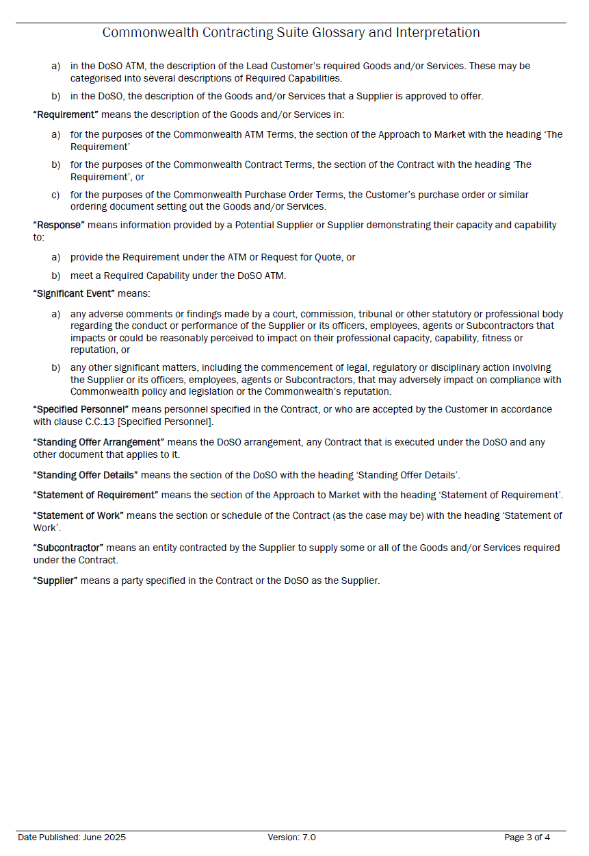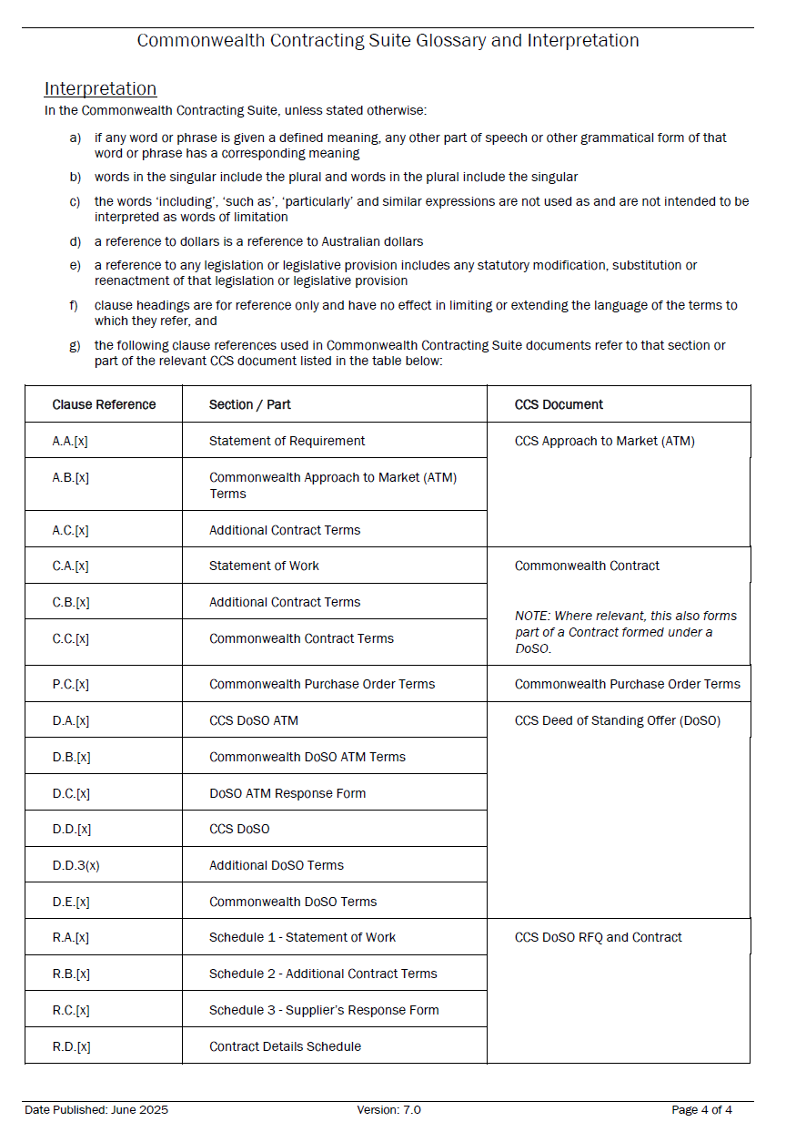
INSTRUCTIONS FOR POTENTIAL SUPPLIER
- Before you start
- This Response is not an offer for work.
- Read all documentation provided by the Customer and distributed with this Response form and decide whether you have the necessary skills and experience to meet the Customer’s requirement.
- Do not proceed further if:
  - You do not meet and/or agree to the Minimum Content and Format Requirements and the Conditions for Participation (if any), set out at item A.A.1 [Key Information and Dates], as failure to do so will mean your response cannot be considered.
- The Customer will evaluate all valid Responses received by the ATM Closing Time [Item A.A.1] that meet the Minimum Content and Format Requirements and the Conditions for Participation (if any), to determine which Potential Supplier has proposed the best value for money outcome for the Customer. Responses will be evaluated as per the criteria set out at Clause A.B.5 [Evaluation].
- Participation in this ATM is at your organisation’s risk and cost. Please note this is a competitive process and your organisation may incur costs in responding. If you are unsuccessful, you will be unable to recoup these costs.
- Format Requirements
- You MUST use this form (CCS ATM Response Form) to submit your Response, which MUST comply with the Commonwealth ATM Terms, available at: https://www.finance.gov.au/government/procurement/commonwealth-contracting-suite-ccs.
- As this form is set out to facilitate the evaluation of responses, Potential Suppliers are to use the form as provided and are not permitted to make any changes to the structure or formatting of the document.
- Guidance for completing your Response
- Specific questions about this ATM must be directed to the ATM Contact Officer set out at Item A.A.5(a) [ATM Contact Officer] before Question Closing Date and Time set out at item A.A.1 [Key Information and Dates].
- In preparation of this Response, please note the Commonwealth Indigenous Procurement Policy (IPP) available at: https://www.niaa.gov.au/indigenous-affairs/economic-development/indigenous-procurement-policy-ipp may apply to the Customer in respect of this procurement. During evaluation of responses, the Customer may consider the Supplier’s ability to assist the Customer to meet its IPP obligations.
- Ensure your Response is as concise as possible while including all information that your organisation wants the evaluation team to consider. Do not include general marketing material or assume that the evaluation team has any knowledge of your organisation’s capabilities or personnel.
- If you are responding as an individual, please complete all sections of the response. List yourself as the Specified Person in item 4.2. References to ‘Potential Supplier’ or organisation can be interpreted as references to the Specified Person.
- If you are an organisation nominating multiple individual experts, please submit separate tenders for each expert. List one individual only per tender as the Specified Person in item 4.2. References to ‘Potential Supplier’ are references to the organisation, not the Specified Person.
- Do not include pricing in any part of your response. The proposed remuneration is provided in the draft Terms of Engagement (Annex A).
- Submit the form as required by Item A.A.4 [Lodgement of Responses].
- If your organisation is unsuccessful with this Response, you may request a debrief to assist with future responses. The ATM Contact Officer set out at Item A.A.5(a) [ATM Contact Officer] can arrange this for you.
Drafting Note:
Before you finalise and submit your Response, please delete all Drafting Notes, including this entire section [Instructions for Potential Suppliers].
Do not type any information within the drafting note guidance tables as any drafting notes remaining in your Response may be removed by the Customer prior to evaluation.

Response to Approach to Market
to establish
Contract for NEA-Technical Expert Reference Group (TERG)
ATM Reference ID: ATM_2026_6984

This Response will be prepared and lodged in accordance with the Minimum Content and Format requirements as set out in A.A.1 [Key Information and Dates]. | ☐ Yes  ☐ No: Do not proceed as your Response will not be eligible for further consideration
This Response will demonstrate my ability to meet the Conditions for Participation as set out in A.A.1 [Key Information and Dates]. | ☐ Yes  ☐ No: Do not proceed as you will not have the ability to fulfil the requirements of the procurement.

Potential Supplier’s Contact Officer
For all matters relating to this Response, the Potential Supplier’s Contact Officer is:
Potential Supplier Name:
Contact Name:
Position:
Telephone:
Email Address:
Postal Address:

Part 1 – Potential Supplier’s Details
Drafting Note:
The following details will appear in the Contract should your Response be successful. The details you provide should be for the legal organisation that would be the Supplier under the Contract.

1.1 Potential Supplier’s Details
Specified Person’s Full Legal Name: | Drafting Note:  Insert the full legal name of the Specified Person listed in item 4.2. If you are successful in this ATM process, this will be the name of the Party in the Terms of Engagement.
Legal Entity Type: | Individual/Sole Trader  Partnership  Company  Sole Director Company  Trust (see note below)  Educational Institution (see note below)  Other (please state):
NOTE FOR TRUSTS: If the Potential Supplier is trading as a trust, please provide details of the relevant trust (and trustee) including a copy of the relevant trust deed (including any variations to that deed) as an attachment to this Response.
NOTE FOR EDUCATIONAL INSTITUTIONS: If your Response is successful, prior to entering a Contract you will be required to provide details of any enabling legislation as well as details of any delegations or other authorisations that are relevant to the execution of a contract.
Australian Business Number (ABN): | Drafting Note:  If the Potential Supplier is an entity registered on the Australian Business Register, then the ABN used by the business must be given.
Australian Company Number (ACN): | Drafting Note:  If the Potential Supplier is an Australian company, then the ACN must be given.
Australian Registered Body Number (ARBN): | Drafting Note:  If the Potential Supplier’s business is an entity registered on the business names register kept under the law of a State or Territory of Australia, then each ARBN used by the business must be given in respect of each State or Territory of registration.
Registered Address: | Drafting Note:  Insert the supplier’s main business address as registered with the Australian Business Register.
1.2 Previous Judicial Decisions
Has your organisation, or where relevant any of its directors, ever had a judicial decision against them (not including decisions under appeal) relating to employee entitlements or engaged in practices that have been found to be dishonest, unethical or unsafe? | Yes, see below.  No
If yes, what was the date of discharge?  The Supplier acknowledges that the giving of false or misleading information to the Commonwealth is a serious offence under section 137.1 of the schedule to the Criminal Code Act 1995 (Cth). | (DD/MM/YYYY)  Note: The Customer cannot enter a contract with a supplier who has an undischarged judicial decision relating to employee entitlements.
1.3 Workplace Gender Equality
Is your organisation classified as a ‘relevant employer’ under the Workplace Gender Equality Act 2012 (the WGE Act)? See https://www.wgea.gov.au/about | Yes, I am a relevant employer  No, I am not a relevant employer
If yes, you are required to provide a current letter of compliance with the WGE Act prior to entering into a contract. Have you provided a letter of compliance with this Response? | Yes  No, I will provide a current letter of compliance prior to contract
NOTE: If the Potential Supplier is successful in this ATM process and where the Supplier is a relevant employer under the WGE Act, the Supplier must provide evidence that it complies with its obligations under the WGE Act before commencement of any Contract and, if the term is more than 18 months, within 18 months of commencement and annually thereafter for the duration of the Contract.
If the Supplier becomes non-compliant with the WGE Act during the course of the Contract, the Supplier must notify the Customer’s Contact Manager in writing within 10 Business Days. Compliance with the WGE Act does not relieve the Supplier from its responsibilities to comply with its obligations under the Contract.
1.4 Indigenous Businesses
Is your organisation:  - 50% or more Indigenous owned?  - a joint venture that is 50% or more indigenous owned which can demonstrate equal indigenous representation and involvement in the management of the joint venture? | Yes – see question below.  No – proceed to section 1.5.
Is your organisation registered on Supply Nation? | Yes  No – see note below  Not Applicable
NOTE: Please provide a certificate or letter from a recognised Indigenous organisation such as Land Council, Indigenous Chamber of Commerce or Office of the Registrar of Indigenous Corporations verifying Indigenous ownership.

1.5 Australian Businesses
Is your organisation:  - a business, including any parent business, that:  - has 50% or more Australian ownership, or is principally traded on an Australian equities market; and  - is an Australian resident for tax purposes; and  - a business that has its principal place of business in Australia.  Further guidance is available at: www.finance.gov.au/australian-business. | Yes – see note below.  No – proceed to section 1.6.
NOTE: The Supplier acknowledges that the giving of false or misleading information to the Commonwealth is a serious offence under section 137.1 of the schedule to the Criminal Code Act 1995 (Cth). The Customer may request information from you to confirm your organisation meets the definition of Australian business.
1.6 New Zealand Businesses
Is your organisation a New Zealand Business as defined in New Zealand’s Government Procurement Rules, available at www.procurement.govt.nz | Yes – see note below.  No – proceed to section 1.7.
NOTE: The Supplier acknowledges that the giving of false or misleading information to the Commonwealth is a serious offence under section 137.1 of the schedule to the Criminal Code Act 1995 (Cth). The Customer may request information from you to confirm your organisation meets the definition of Australian business.
1.7 Potential Supplier’s Contract Manager
Drafting Note:
Provide details for the person you propose will be the Contact Manager if your Response is successful and your organisation is awarded a contract.

For matters relating to the proposed Contract, the Potential Supplier’s Contract Manager will be:
Name:
Position Title:
Telephone:
Mobile:
Email Address:
Postal Address:

1.8 Potential Supplier’s Address for Notices (if different from the Contract Manager)
Drafting Note:
Complete with “AS ABOVE” if same as Contact Manager.

Name:
Position Title:
Email Address:
Postal Address:

Part 2 – Conditions for Participation
2.1 Conditions for Participation
Drafting Note:
Respond to the Conditions for Participation here. Do not proceed further if you cannot meet the Conditions for Participation as your Response cannot be considered. The Customer will exclude from consideration any Response that does not meet the Conditions for Participation.

Participation condition | Condition met (select if yes) | Provide any comments if necessary
The Specified Person in item 4.2 is an Australian resident | ☐
The Specified Person holds relevant postgraduate qualifications and/or at least 10 years of professional experience in nominated areas of expertise | ☐

2.2 Nominated areas of expertise
Please complete the table below to nominate the Specified Person’s area/s of expertise
Area of expertise | Select
Developing accounts using the UN System of Environmental-Economic Accounting, official statistics production, or accounts production at large scales | ☐
Coastal and marine ecology, including ecosystem extent, condition and biodiversity | ☐
Freshwater ecology, including ecosystem extent, condition and biodiversity | ☐
Terrestrial ecology, including ecosystem extent, condition and biodiversity | ☐
Valuation of ecosystem services, including physical and monetary values | ☐
Spatial data architecture and intelligence systems | ☐

2.3 Relevant postgraduate qualifications and/or professional experience
Does the Specified Person hold relevant postgraduate qualifications and/or at least ten years of professional experience in their nominated areas of expertise? | ☐ Yes  ☐ No
If yes, please ensure this is clearly demonstrated in the CV of the Specified Person

Part 3 – Ability to Meet the Requirement
3.1 Response to selection criteria
Drafting Note:
The response below should address the selection criteria described in the Requirement, for the Specified Person listed in 4.2. The relevant selection criteria are:
- Extent to which the Potential Supplier’s response meets the Customer’s Requirement set out in this ATM
- Extent to which the Potential Supplier demonstrates its capability and capacity to provide the Requirement; and
- Demonstrated subject matter expertise.
No response is required for the whole of life costs criterion as all TERG members are paid the same rate.
A maximum of 750 words is required.

3.2 Geographic locations of expertise
Drafting Note:
Please provide a short description (max 200 words) of the geographical location/s of the expertise of the Specified Person. This may differ from where they are currently located.

3.3 Unique contribution to the TERG
Drafting Note:
Please provide a short description (max 200 words) of how the Specified Person would provide a unique contribution to the TERG. This may include the unique perspective they can bring because of their location, gender, age, cultural background, First Nations identity, skills and experience.

- Commonwealth Supplier Code of Conduct
Has the Potential Supplier ever been investigated for a potential breach, or has been found to have actually breached, the Commonwealth Supplier Code of Conduct in connection with a Commonwealth contract? | ☐ Yes, see below.  ☐ No
If yes, provide further details:
Drafting Note:
Where requested by the Customer at A.A.2(a), provide information demonstrating that you have appropriate policies, frameworks, or similar, in place to comply with the Commonwealth Supplier Code of Conduct. While you may include general information, try and focus your response to any specific aspects of the Code identified and any specific information requested above.
If A.A.2(a) does not specify compliance information, type “Not Applicable” below.

Not applicable.

- Standards
Drafting Note:
Provide full details and evidence of compliance with all applicable Australian standards, and any Australian and international standards and requirements specified in The Requirement. Potential Suppliers are encouraged to demonstrate how any standard(s) are proposed to be specifically used in the delivery of the goods/services (i.e. provide evidence that demonstrates how your organisation complies with applicable standards in the context of the requested goods/services and attach supporting evidence as necessary).
Where you do not propose to comply with a standard which has been included in The Requirement, propose an alternative standard and justify your reasons. Where no standard has been specified, list any applicable standards with which you propose to comply.
Type “Not Applicable” below if no standards apply.
Not applicable.

Part 4 – Potential Supplier’s Demonstrated Capability and Capacity
4.1 Curriculum Vitae
Drafting Note:
This section can be used to provide a maximum 2-page curriculum vitae detailing the Specified Person’s relevant skills and experience to deliver the services. The CV should demonstrate that the Specified Person holds postgraduate qualifications and/or at least 10 years of professional experience relevant to the nominated areas of expertise. Alternatively, you may leave blank and attach the document separately.

4.2 Specified Personnel
Drafting Note:
Only propose Specified Personnel where your proposal has referenced the skills of specific personnel and you reasonably expect them to perform the roles nominated. Include their role, the percentage of the project they will complete, and if relevant, their current Commonwealth Government security clearance.
Only one Specified Person should be submitted per tender response.

Name | Position/Role | Current Security Clearance Level# | Percentage of  Total Project Time
 | TERG member | Not relevant | 100%
Total personnel time |  |  | 100%
# if requested at A.A.2(b)

4.3 Capacity and availability
Does the Specified Person have the capacity and availability to participate in TERG activities consistent with the Terms of Reference (Annex B)? | ☐ Yes  ☐ No/unsure
If unsure, please provide details of any significant limitations on the availability of the Specified Person:

4.4 Participation in other advisory groups
Is the Specified Person currently providing any other advisory services to the Australian Government through participation in advisory committees, expert panels, working groups or similar? | ☐ Yes, see below.  ☐ No
If yes, provide further details:

4.5 Subcontractors
Drafting Note:
The Customer may be required to publicly disclose information about subcontractors. Provide details for each subcontractor organisation you will use below.
In support of the Indigenous Procurement Policy (https://www.niaa.gov.au/indigenous-affairs/economic-development/indigenous-procurement-policy-ipp), also highlight any Indigenous subcontractors you are proposing to use, or any Indigenous staff who will work on the project.
If no subcontractors are proposed insert “Not Applicable”
Not applicable

  - Scope of Works to be Subcontracted
Drafting Note:
If no subcontractors are proposed insert “Not Applicable”.
Provide details of the roles (or specific parts of the contract) each subcontractor will perform.
The Supplier is solely responsible for all obligations under the Contract, including subcontractor performance and management. The Supplier must ensure that any subcontract arrangement that is entered into imposes necessary obligations on the subcontractor.
If you are intending to include subcontractors, read and understand your obligations under the Commonwealth Contract Terms, Subcontracting [Clause C.C.10], Relationship of the Parties [Clause C.C.2], Compliance with the Laws and Policy [Clause C.C.21] specifically relate to subcontractors.
Not applicable
4.6 Conflicts of Interest
Drafting Note:
Commonwealth officials have an obligation to disclose Conflicts of Interest under section 29 of the Public Governance, Performance and Accountability Act 2013 (Cth). Suppliers to Commonwealth entities need to assist the Commonwealth to meet its obligations by complying with the same standard of conduct.
Conflicts can be real or apparent. The perception of a conflict can be just as damaging to the public’s confidence in public administration as an actual conflict based on objective facts.
Provide full details of any Conflicts of Interest (if any) that could arise as a result of entering into the Contract with a Customer and propose a strategy to manage the conflict. For complex issues, you may choose to attach a Conflict of Interest Management Plan detailing your proposed approach.
After this response is submitted, Potential Suppliers must report any Conflicts of Interest that may have arisen or been identified during the evaluation period to the Customer without delay.
If no Conflicts of Interest were identified, type “Nil”.
The Potential Supplier has identified the following potential Conflicts of Interest and management strategies:
Details | Management Strategy
4.7 Referees
Drafting Note:
Provide daytime contact details for two (2) referees who can attest to the Specified Person’s capacity to meet the Requirement. A reference is stronger if your organisation and/or Specified Personnel has recently provided the referee with similar goods/services. It is good practice to ensure that nominated referees are aware they may be contacted.
Note clause A.B.5 [Evaluation]: The Customer reserves the right to contact any referees, or any other person, directly and without notifying the Potential Supplier.

Referee Name | Position | Organisation | Phone Number |  | Email Address

4.8 Pre-existing Intellectual Property of Potential Supplier
Drafting Note:
List your pre-existing Intellectual Property (if any) noting that:
The Supplier grants to, or in the case of Third-Party Material, must obtain for, the Customer a non-exclusive, irrevocable, royalty-free, perpetual, world-wide licence (including the right to sub-licence) to exercise the Intellectual Property Rights in all Pre-existing Material and Third- Party Material incorporated into the Material to enable the Customer to receive the full benefit of the Goods and/or Services and the Material and to exercise its rights in relation to the Material.
If no pre-existing Intellectual Property is proposed insert “Not Applicable”.
Not applicable.

4.9 Confidentiality of Potential Supplier’s Information
Drafting Note:
Identify any information in your Response, or the proposed Contract, which you consider should be kept confidential, with reason(s).
The Customer will only agree to treat information as confidential in cases that meet the Commonwealth’s guidelines and which the Customer considers appropriate. If the Customer does not agree that the information meets the guidelines to be treated as confidential, the Customer has the right to disclose any information contained in the Contract.
Information to assist you to assess whether the Customer is able to treat particular information as confidential is available at: https://www.finance.gov.au/publications/resource-management-guides/procurement-publishing-and-reporting-obligations-rmg-423.
If none, type “Not Applicable”.
Add extra lines to the table as required.
The Potential Supplier has assessed that the commercial information in the table below meets the requirements available at https://www.finance.gov.au/government/procurement/buying-australian-government/additional-reporting-confidentiality and is seeking that information be kept confidential.
Information to be kept Confidential | Reasons for Confidentiality Request
4.10 Additional Information
Drafting Note:
Any information included here should be relevant to this proposal and should be as concise as possible.
To facilitate the Customer’s reporting responsibilities under the Indigenous Procurement Policy, if you are an Indigenous business, have Indigenous employees, or are proposing Indigenous subcontractors you should highlight that information here and explain how you will report the ongoing participation of Indigenous people in fulfilling the proposed Contract.
To facilitate the Customer’s reporting responsibilities, if you are a business that primarily exists to provide the services of persons with a disability highlight that information here and explain how you will report ongoing participation of disabled people in fulfilling the proposed Contract.
The Commonwealth’s Fraud Control Framework requires the Customer to manage risk of fraud and corruption as part of contracting and procurement activities. You should include details of controls (if any) you will have in place to prevent fraud and corruption against the Commonwealth.
This section should NOT be used to include generic marketing information that is not specific to the Requirement.

