009b_Template_Mouse Body Condition Score_V1.0
Mouse Body Condition Score Guidance
This document outlining the use of body condition scoring in mice is in support of the use of the AEC Approved Document_009_Template_Mouse Score System_V3.0. The use of the Mouse Score System and Mouse Body Condition Score documents ensures that there is a consistent approach to assessing animal welfare across the University, and allows for clearer and more efficient communication between researchers, animal technicians and veterinary staff, and ultimately, better welfare outcomes.
Body condition scoring is a non-invasive and low stress way of assessing general health in mice, and, when used in conjunction with the Mouse Score System, can be used to assess welfare and define endpoints during research. Mice that are under conditioned may have underlying health conditions that need to be addressed, and will require supportive care. Obese mice may also have underlying conditions that require management, and may develop secondary issues relating to their obesity (e.g. reduced mobility, urine scalding) that need to be managed.
Scores are determined by visual assessment and palpation. The scale ranges from 1, emaciated, to 5, obese, with 3 being the optimal body score. Scores are reported out of the total used, i.e. an emaciated mouse would be reported as a body condition score of 1/5.
Body condition scoring is particularly useful when there are tumours present, fluid in the abdomen (ascites), when mice are pregnant, or in young growing mice, where weight may remain stable despite deteriorating condition.
To assess the mouse:
- When opening the cage, visually inspect the mouse, paying attention to the shape of the abdomen, whether any tumours or growths are present, and whether the spine, ribs or dorsal pelvic (hip) bones can be seen.
- The mouse is then gently restrained at the base of the tail with one hand, while the other hand is used to palpate over the rib cage, spine and pelvis (hips).
- Using the guide below, match your findings to the descriptions listed to determine the score. If a mouse is between scores, this can be expressed in increments of 0.5, eg. a mouse sitting between a score 2 and a score 3 could be assigned a score of 2.5/5.
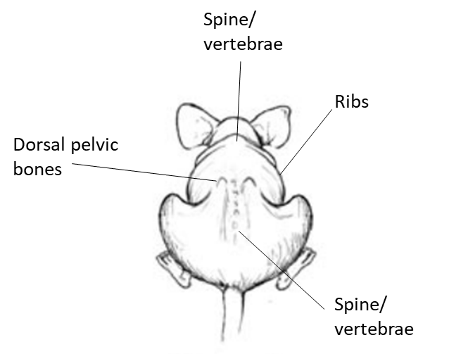
Mouse Body condition score

 | Description | Example Diagram
1 | The mouse is emaciated  - The spine, pelvis and ribs will be prominent when visually assessing the mouse  - On palpation, the ribs, spine from pelvis to neck and dorsal pelvic bones will be easily felt  - The *vertebrae can be felt individually | 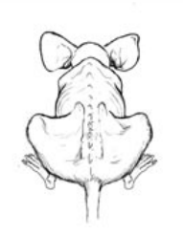
2 | The mouse is under conditioned  - The spine may be prominent when visually assessing the mouse  - On palpation, the spine and dorsal pelvic bones are easily felt, but with some muscle either side of the spine present | 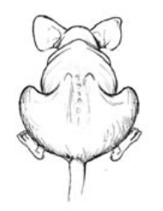
3 | The mouse is well conditioned  - The outlines of the ribs, spine and pelvis are not able to be visualised  - On palpation, the spine and dorsal pelvic bones can be felt with slight pressure | 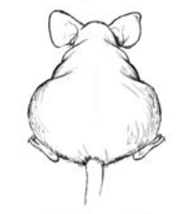
4 | The mouse is over conditioned  - The outlines of the ribs, spine and pelvis are not able to be visualised, and the mouse is a round shape when viewed from above  - On palpation, the spine and dorsal pelvic bones can only be felt with firm pressure, with fat palpable over ribs, spine and pelvis | 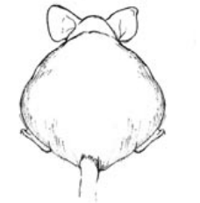
5 | The mouse is obese  - The outlines of the ribs, spine and pelvis are not able to be visualised, and the mouse may be as wide as it is long  - On palpation, the spine and dorsal pelvic bones cannot be felt and the mouse is generally smooth and bulky | 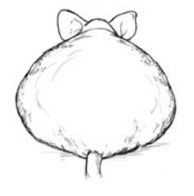
*The spinal column is made up of many individual vertebrae
Table adapted from: Burkholder, T., Foltz, C., Karlsson, E., Linton, C.G. and Smith, J.M. (2012), Health Evaluation of Experimental Laboratory Mice. Current Protocols in Mouse Biology, 2: 145-165. https://doi.org/10.1002/9780470942390.mo110217

